**Project Report Template**

1 **INTRODUCTION**

1.1 **Overview**

Higher Education Software from Salesforce

Salesforce.org Education Cloud is the complete customer relationship management software for colleges and universities, helping you track all your constituent relationships, from prospects and students to alumni and donors. EDA, the Education Data Architecture for Salesforce, provides an education data model for a complete view of students, courses, programs, and more. Education Cloud provides solutions across the student lifecycle, including recruitment CRM, enrollment management, academic advising, and alumni database. Education Cloud helps you become a Connected Campus by bringing together education data through system integration, connecting your institution’s student information system, student management system, school management system, and other school software.

1.2 **Purpose**

The use of this project. What can be achieved using this?

In the article, we explore some fundamental reasons behind why CRM projects fail and how to achieve success. Although we allude to ‘sales teams’ and ‘businesses’, our thinking can easily be applied to a higher education context.

Customer relationship management systems (CRMs) work wonders for student recruitment in universities around the world every day.

If implemented and managed properly, they have the power to minimum workloads, streamline communications and ultimately convert more candidates into enrolled students. “FULL FABRIC [CRM] helped us digital the whole admission process which not only improved the applicant experience but also made the review and selection process much easier”, says Emma Spittles, Scholarships program Manager at Said Foundation.

The success stories are numerous, but what happens when a CRM project goes wrong? Or more specifically, why do some implementations end in disaster?

This is the subject of Scott Edinger’s thought-provoking piece for the Harvard Business Review, titled ‘Why CRM Projects Fail and How to Make Them More Successful’.

In the article, he explores some fundamental reasons behind why they fail and how to achieve success. Although he alludes to ‘sales teams’ and ‘businesses’, his thinking can easily be applied to a higher education context.

2 **Problem Definition & Design Thinking**

2.1 **Empathy Map**

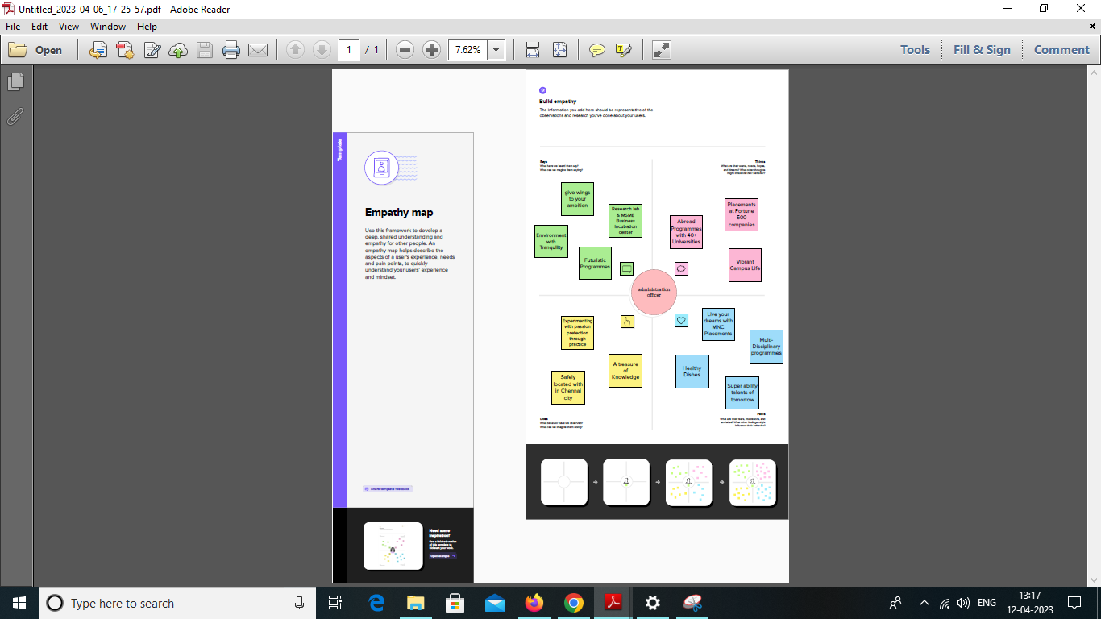

2.2 **Ideation & Brainstorming Map**

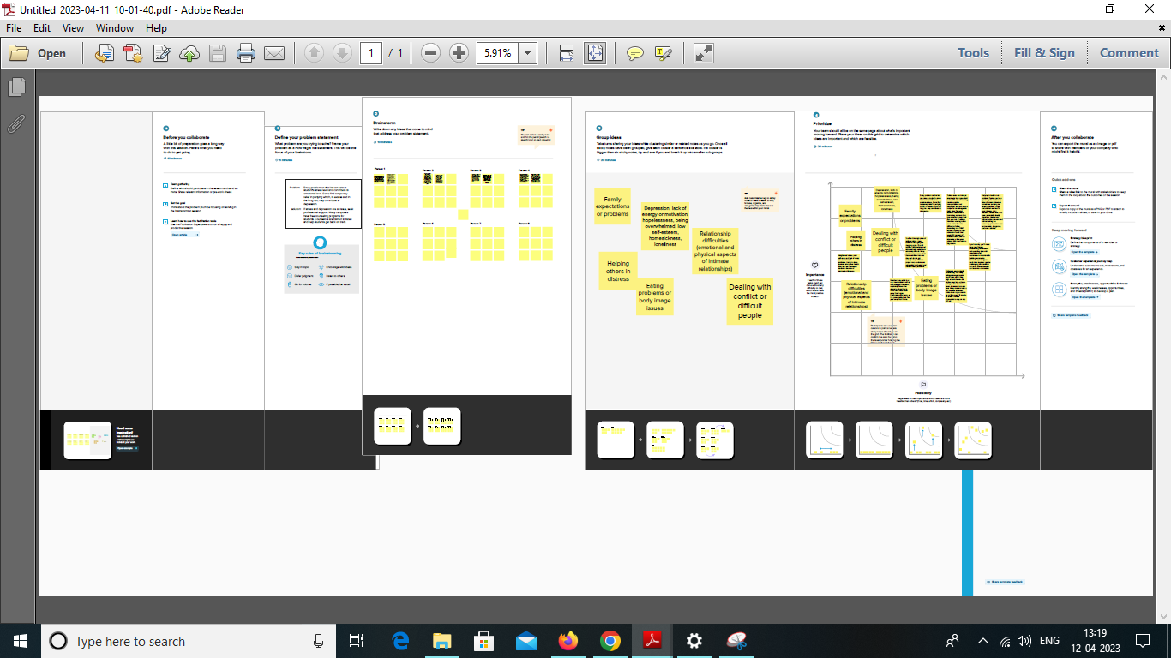

3 **RESULT**

3.1 **Data Model:**

|  |  |
| --- | --- |
| Object name | Fields in the Object |
| Obj1  Schools | |  |  | | --- | --- | | Field label | Data type | | school Name | Text (80) | | school websites | Text Area (255) | | phone number | phone | | address | Text Area (255) | | District | Text Area (255) | | State | Text Area (255) | |
| obj2  Students | |  |  | | --- | --- | | Field label | Data type | | Student name | Text (80) | | class | Number(18, 0) | | Number of student | Roll-Up Summary (COUNT school) | | Phone number | phone | | marks | Number(18, 0) | | Highest mark | Roll-Up Summary (MAX school) | | result | Picklist | |
| obj3  Parent | |  |  | | --- | --- | | Field label | Data type | | Parent name | Text (80) | | Parent address | Text Area (255)/ | | Parent number | phone | |

3.2 **Activity & Screenshot**

Attach the screenshots of your project activity along with the

description.

4 **Trailhead Profile Public URL**

Team Lead - <https://trailblazer.me/id/dkumar2058>

Team Member 1 - <https://trailblazer.me/id/magesh2001>

Team Member 2 - <https://trailblazer.me/id/sudhd18>

Team Member 3 - <https://trailblazer.me/id/veni30>

5 **ADVANTAGES & DISADVANTAGE**

List of advantages of the proposed solution

1. Its most useful for my salesforce related skills

2. We have learned lot of thinks

3. Customer-centric automation.

4. Proactive service

5. Simplified collaboration

6. A single view of the customer for cross-functional insight and reporting.

List of disadvantages of the proposed solution

Many customers claim that Salesforce customer service is unresponsive, and some emails and calls can remain unanswered for months. Also, when users reach out to support for help, they seem not to have a solution for their problem.

6 **APPLICATIONS**

Salesforce is the world's #1 customer relationship management (CRM) platform. We help your marketing, sales, commerce, service and IT teams work as one from anywhere — so you can keep your customers happy everywhere.

7 **CONCLUSION**

Salesforce CRM is a cloud-based platform which helps you to manage sales, marketing, lead generation, customer service and many other functions. Hope You got more information about the benefits of using the Salesforce platform and what it does.

8 **FUTURE SCOPE**

Salesforce is a business that specializes in customer relationship management and provides software as a service (SaaS) for cloud technology (CRM). With the help of Salesforce's services, organizations can leverage cloud computing to engage with their current and potential clients and partners more effectively.